**Code 1:**

1. **Write a program in C++ to find the sum of first 10 natural numbers**

#include<iostream>

using namespace std;

int main(){

int i,y,sum=0;

for(i=1;i<11;i++){

cin>>y;

sum+=y;

}

cout<<"sum of ten numbers is "<<sum<<endl;

}

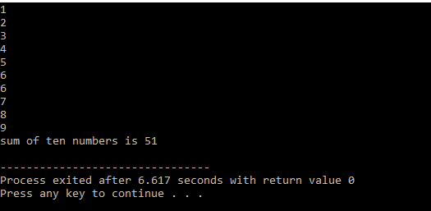

**Code2 :**

**Write code to print table of any number**

#include<iostream>

using namespace std;

int main(){

int number;

cout<<"enter number for table"<<endl;

cin>>number;

cout<<"table of"<<number<<"is"<<endl;

for(i=1;i<11;i++){

cout<<number<<"*"<<i<<"="<<number*i<<endl;

} }

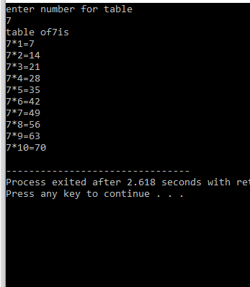

**Code 3:**

**Write program to find factorial of any number.**

#include<iostream>

using namespace std;

int main(){

int x;

int factorial;

cout<<"enter number for factorial"<<endl;

cin>>x;

factorial = x;

for(i=x-1; i>0; i--){

factorial*=i;

}

cout<<"factorial is "<<factorial<<endl;

}

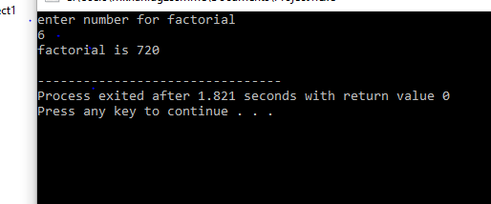

**Code 4:**

**Write code to find Fibonacci sequence upto any number taken by user .**

#include <iostream>

using namespace std;

int main() {

int num1, num2, num3, maxnum;

cout << “Enter the max number to go to” << endl;

cin >> maxnum;

num1 = 0;

num2 = 1;

num3 = 1;

cout << num1 << endl;

cout << num2 << endl;

cout << num3 << endl;

while (num3 <= maxnum) { // Change the condition to <=

num1 = num2;

num2 = num3;

num3 = num1 + num2;

if (num3 <= maxnum) {

cout << num3 << endl;

}

}

Return 0;

}

